**EG2401A module, Sem I, Aug/Sep 2021**

Welcome to EG2401A module!!... :-):-)… View this file first!!

**EG2401A schedule and ZOOM links “info” (via EG2401A LUMINUS -> Conferencing) for Lectures 1,2,3**

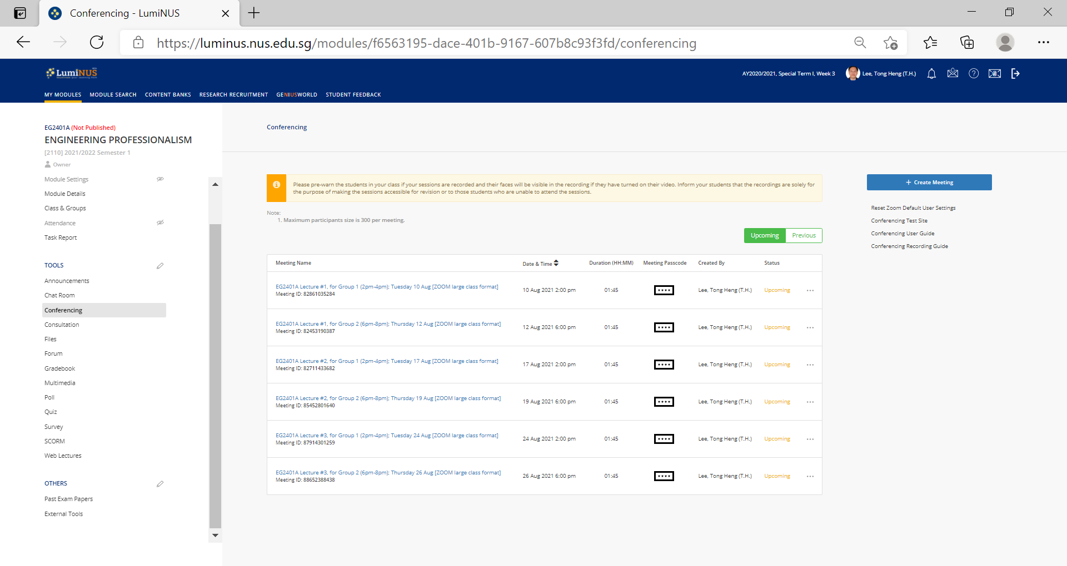

**Enlarged below…**

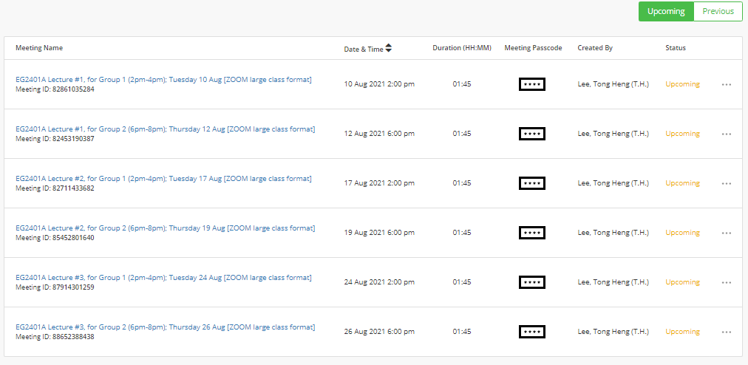

**Due to COVID-19 management arrangements, the lecture classes in the module will be conducted online via ZOOM. Please see above for the schedule as well as the ZOOM “info” details for the respective Lectures 1,2,3.**

For more instructions/help, refer to <https://wiki.nus.edu.sg/display/cit/Zoom#Zoom-SignIn>

**Look forward to our module!!... :-):-)**